

Lab 02 - Terraform

Submitted to: Tariq Ghouri



Submitted by:

Muhammad SOban Mallick - 2112158

Muhammad Umer - 2112155

**Part 1: Prepare for the Lab (CMD)**

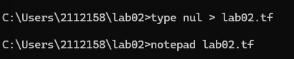

### ****Part 2: Write Terraform Code****

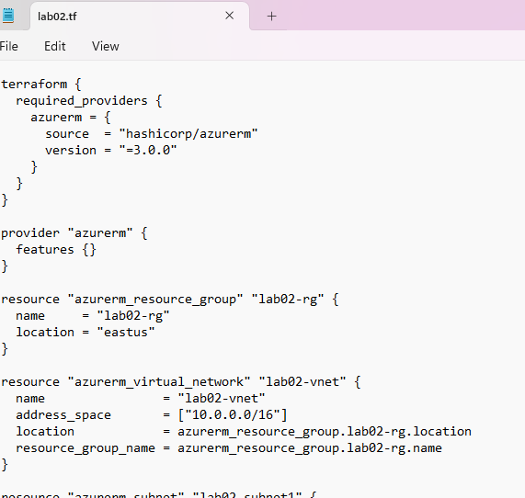

### ****Part 3: Initialize Terraform (CMD)****

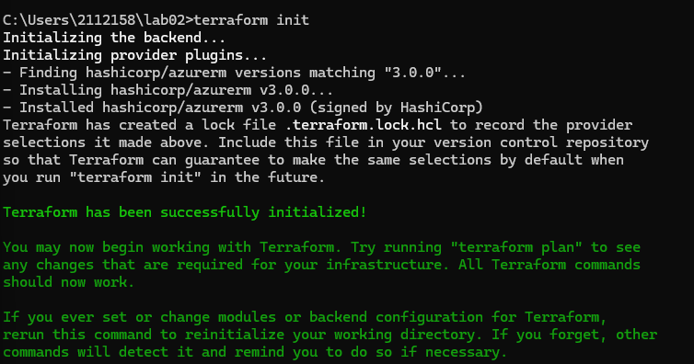

### ****Part 4: Validate Configuration (CMD)****

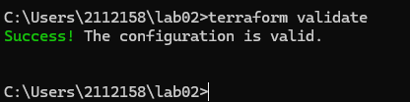

### ****Part 5: Dry Run (Plan)****

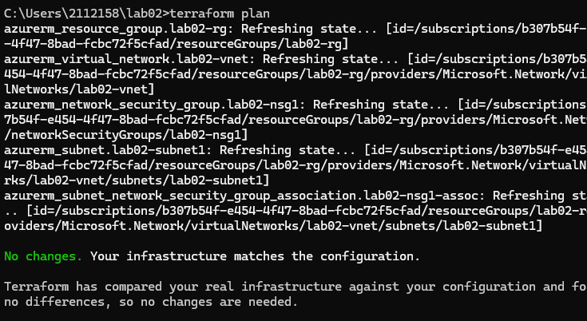

### ****Part 6: Deploy (Apply)****

### 

### 

### ****Part 7: Check Terraform State****

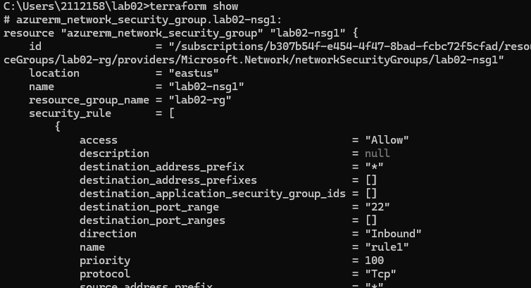

### ****Part 8: Verify in Azure Portal****

### 

### ****Part 9: Expand****lab02.tf

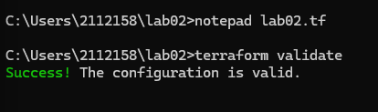

### ****Part 10-12: Validate, Plan, Apply Again****

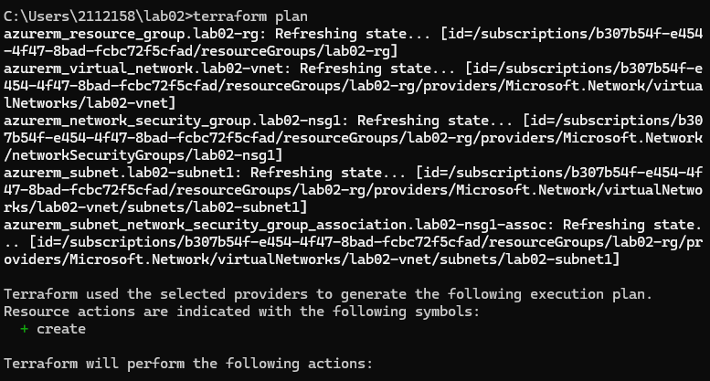

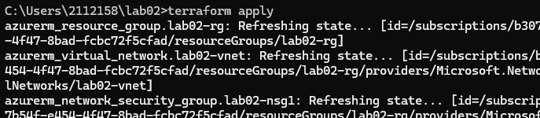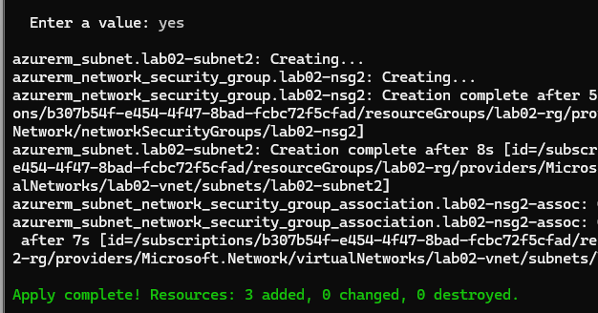

### ****Part 13-14: Verify State & Azure Portal****

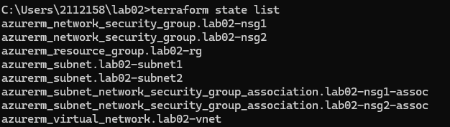

### ****Part 15: Destroy All Resources****

